ANSWERS TEST 2 EQUILBRIUM
Teacher:

PART 1:
Questions 1-10 (10 marks)

1 | a b c d
2 | a b c d
3 | a b c d
4 | a b c d
5 | a b c d
6 | a b c d
7 | a b c d
8 | a b c d
9  10 | a b c d  a b c d

PART 2: WRITTEN SECTION (40 marks)

1. Methane and water react to produce carbon monoxide and hydrogen according to the equation:

CH₄(g) + H₂O(g) ⇄ CO(g) + 3 H₂(g) ΔH = +200 kJ mol⁻¹

Assume the reaction is allowed to come to equilibrium at 200^{O}C and a pressure of 150kPa.
Using the terms: INCREASE, DECREASE, NO CHANGE, answer (a), (b) and (c):

- Once the equilibrium has been re-established, how will the VALUE of the equilibrium constant change if:

(i) the volume of the vessel is halved NO CHANGE

(ii) the temperature is raised to 500^{O}C INCREASE

- Once the equilibrium has been re-established, what happens to the equilibrium concentration of carbon monoxide if the following changes occur?

- Water gas is added to the system INCREASE

(ii) The pressure of the reaction vessel is doubled by adding argon gas
(assuming volume and
temperature are kept constant) NO CHANGE

- The temperature is decreased to 100^{O}C DECREASE

- What happens INITIALLY to the rate of the forward reaction if the following changes are made?

- More CO gas is added to the mixture INCREASE / NO CHANGE

- The volume of the container is halved INCREASE

(ii) A suitable catalyst is added INCREASE (8 marks)

2. Consider a solution in which the following equilibrium is established:
Br₂(aq) + 2OHˉ (aq) ⇄ OBrˉ(aq) + Brˉ(aq) + H₂O(l) ΔH = +15kJ mol⁻¹

The molecular bromine (Br₂), gives the aqueous solution a reddish brown colour. All the other species present are colourless.

(a) The tests described in the table below are carried out on separate 5 mL samples of the solution. For each of the tests, give any observations from when the change is made initially, until equilibrium has been re-established and, in each case, give an explanation for your answer.

 | Observations | Explanation
Test 1:  2 mL of a concentrated solution of bromine is mixed into the solution.  (3 marks) | Initially: darker red, then becomes paler | Increasing [Br₂] causes initial darkening.  Having higher concentrations of a reactant increases frequency of collisions between reactant particles. This causes the rate of forward reaction to be greater than reverse, hence Br₂ is used up and the solution becomes lighter.
Test 2:  2 mL of water is added to the solution.  (3 marks) | Initially:  Appears paler  Then, solution becomes darker | Initially, dilution causes the solution to be paler as [Br₂] decreases.  Having lower concentrations of particles decreases frequency of collisions between them. The reverse reaction rate (less aq species colliding) decreases by a smaller amount than the forward to produce a higher concentration of the reactant aqueous species.
Test 3:  The solution is heated from room temperature to 60ºC.  (2 marks) | Solution becomes paler. | Higher temperature increases frequency of collisions between particles. Forward reaction rate (endothermic) is increased by more than the reverse reaction rate in order to absorb the extra energy.
(8 marks)
(b) Write the expression for the equilibrium constant (K) for the reaction: (1 mark)

K = [OBrˉ] [Brˉ ]
[Br₂] [OHˉ]²

(c) Sketch graphs of what happens to the rate of the forward and reverse reactions for test 3, from before the change is made until equilibrium has been re-established at t₁. Clearly indicate which graph represents the forward reaction and which represents the reverse. (2 marks)
Fwd

Rev
Rate of reaction

Test 3 t₁Time
occurs

3. Part of the contact process for the manufacture of sulphuric acid involves the conversion of sulfur dioxide to sulfur trioxide as shown by the equation:

2SO₂(g) + O₂(g) ⇄ 2SO₃(g) ΔH = -192kJ mol⁻¹

As part of a laboratory study of the process, a container was filled with an equilibrium mixture of SO₂, SO₃ and O₂ in the presence of a catalyst. The container was originally at 450ºC. The container had a fixed volume and was thermally well insulated. Concentrations recorded during the following experiment are shown in the diagram below:
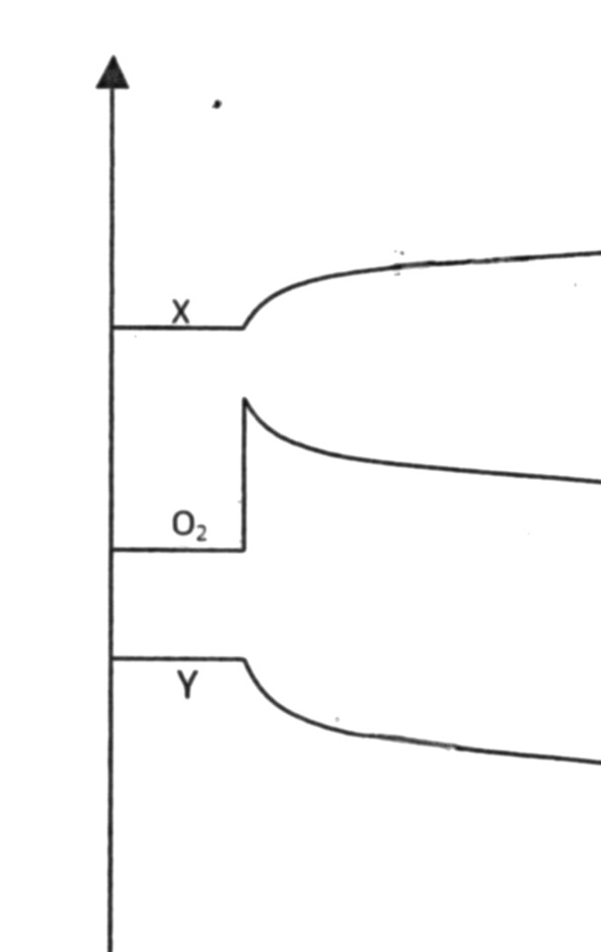

Concentration
molL⁻¹

0 5 10 15 20 25 30 35 40 Time (minutes)

- At t=5 minutes, what was the change which was made to the system? (1 mark)

Concentration / partial pressure of oxygen is increased.

(b) Which components of the equilibrium mixture are represented by X and Y?

X is SO₃ Y is SO₂ (2 marks)

(c) Would the temperature of the mixture increase, decrease or remain the same between 5 and 20 minutes? Explain your reasoning. (2 marks)

The temperature INCREASES (1) due to equilibrium favouring forward exothermic reaction releasing energy to the system. (1)

(d) At t = 20 minutes, some SO₃ was removed from the container. Continue the graph to represent the changes made to the concentrations of X, Y and O₂ until equilibrium has been re-established at 35 minutes.
(1 mark each graph) (3 marks)

4. Nitroglycerine (C₃H₅(ONO₂)₃ is used in explosives. Its decomposition is shown by the following equation.

4C₃H₅(ONO₂)₃(l) 6N₂(g) + 12CO₂(g) + 10H₂O(g) + O₂(g)

Calculate the total volume of nitrogen gas produced, if 16.60 g of nitroglycerine liquid completely decomposes at 500ºC and at 150 kPa pressure.
(4 marks)

Moles of nitro = 16.60/227.1= 0.07309 moles (1)

From equation, moles of nitrogen = 6/4 x 0.07309= 0.10964 moles (1)

PV = nRT

V = nRT/P = 0.10964 x 8.314 x 773 = 4.70L (2)
150

5. 2.120 g of pure sodium carbonate was dissolved in water and the solution added with stirring to 10.0mL of 1.00 molL⁻¹copper(II) nitrate solution. The resulting precipitate of insoluble copper(II) carbonate was then washed and redissolved in a slight excess of sulphuric acid. After slow evaporation, the resulting copper(II) sulfate was recovered as light blue crystals of the pentahydrate.

The molecular equations for the above chemical processes are given below.

Na₂CO₃ _{(aq)} + Cu(NO₃)₂ _{(aq)} → 2NaNO_{3 (aq)} + CuCO₃ _{(s)}

CuCO₃ _{(s)} + H₂SO₄ _{(aq)} → CuSO_{4 (aq)} + H₂O _{(l)} + CO_{2 (g)}

- Write the ionic equations for the reaction of:

- Sodium carbonate solution and copper(II) nitrate solution.

Cu²⁺(aq) + CO₃²⁻ (aq) CuCO₃(s)

- Copper(II) carbonate and sulfuric acid.

CuCO₃(s)+ 2H+(aq) Cu²⁺(aq) + H₂O + CO₂(g)
- marks)

(b) Calculate the mass of copper(II) carbonate precipitate formed. (4 marks)

Na₂CO₃ + Cu(NO₃)₂ 2NaNO₃ + CuCO₃(s)

2.12g 10.0mL 1M

Moles Na₂CO₃ Moles Cu(NO₃)₂ (2)

= 2.120/105.99 = 1 x 0.010
= 0.02mol = 0.01 mol

Hence Cu(NO₃)₂is the limiting reagent.

From equation, Moles CuCO₃ = 0.010mol (1)

Mass = 0.010 x 123.55

= 1.23 g (1)

(c) Calculate the mass of copper(II) sulfate pentahydrate crystals, assuming complete recovery.
(3 marks)
CuCO₃+ H₂SO₄ CuSO₄ + H₂O + CO₂(g)

Moles CuCO₃ = 0.010mol (1)

From equation, MolesCuSO₄.5H₂O = 6.543 x 10⁻³mol (1)

Mass CuSO₄.5H₂O = 0.01x 249.61
= 2.49 g (1)

END OF TEST

